# Configuring Drives for a nominal state

You must know the Maestro’s IP address before trying to connect. On the OH20 Head 1 the specific IP address is 192.168.1.50

Maestro EtherCAT configuration

If you know the IP address it can be configured.

1. Click connect on the EAS 2 software
2. Maestro should have a green dot beside it
3. Go to EtherCAT and click Edit
   1. If there is no EtherCAT configuration then you must create a new one
4. Import the GoldWHI template and apply to all axes
5. Rename all the axes to the corresponding physical spool positions
   1. The physical address is the chain location

Drive Configuration (Assuming FLA-20 48VDC)

1. Connect to each individual drive using the gateway
2. Go to Drive Setup and Motion: Expert Tuning
3. If a .gprm textual parameters file is available, perform a textual download
4. Axes Configurations:
   1. Single Axis
   2. Rotary Motor Rotary Load
   3. Dual Feedback
   4. Velocity Mode
5. Motor Settings
   1. Rotary Brushless (3 Phase)
   2. Peak Current: 25.17Arms
   3. Continuous Stall Current: 8.49 Arms
   4. Max RPM: 360
   5. Pole Pairs Per Revolution: 8
6. Feedback Settings
   1. Feedback on Motor
      1. Encoder Quad, Port B
      2. Lines/Rev 6208
      3. Counts/Rev 24832 (Automatically 4x Lines/Rev)
   2. Feedback on Load (Same as motor feedback)
7. Advanced Feedback
   1. Socket 1 Encoder Quad, Port B (Output of gearbox measurement)
   2. Socket 2 Encoder Quad, Port A (Linear dancer 1um)
   3. Socket 3 Halls only, Port A
      1. 48 Counts per revolution
      2. Only for Commutation
   4. Position Feedback Socket Source: Socket 1
   5. Velocity Feedback Socket Source: Socket 1
   6. Commutation Feedback Socket Source: Socket 3
8. User Units
   1. Position: Other (U) 24832 (User Defined in Revolution)
   2. Velocity: RPM (~413.866 Automatically calculated)
9. Current Limits
   1. Using the DC Whistle 20A/100V Version
   2. Peak current specified to be 40A
   3. Peak duration, probably 5x taus, 0.5s
10. Motion Limits
    1. Stop Decel: 5080RPM/s
    2. Max Velocity Command: 360RPM
    3. No Modulo
11. Identify and make the overshoot around 0-5%
    1. Gain 1.42
    2. Integral 126Hz
    3. Use above constants as starting point if no identification is done
12. Commutation with CL 100, 1.4el, 0.5 Vel
    1. If this does not work, more displacement can work
    2. Should see Hall state oscillations
13. Velocity and Position
    1. Starting parameters
       1. Scheduling Off
       2. Velocity Gain A/cnt/sec (4.19E-3)
       3. Velcoity Integral 0.5
       4. Position Gain 0
       5. Acc FF 0
       6. Velocity FF 0
       7. 200Hz, 0.5 Damp Low pass
    2. Found parameters 3.1E-3 for gain and 0.5Hz worked alright for empty spool
    3. Found parameters 2.5E-3 for gain and 0.25Hz FF = 0.00005 worked well for large and empty spools
14. Maestro configuration for touch probe
    1. Maestro Setup and Motion
    2. Select the drive over the device network
    3. Set touch probe to desired input
       1. Socket 1 (Position)
       2. Touch Probe Source: Input 2

Connecting digital 1 to STO status

1. Connect to the terminal
2. GO[1]=7
   1. Sets the digital output 1 to connect to the STO output

In case of bugs related to selecting the proper feedback

1. CA (Commutation Array)
2. CA[41] = 1
   1. CA[41] is Socket 1, = 1 connects to Quad Encoder on Port B
3. CA[42] = 2
   1. CA[42] is Socket2, = 2 connects to Quad Encoder on Port A
4. CA[43] = 4
   1. CA[43] is Socket 3, = 4 Connects to the Hall sensors, assumed to be Port A
5. CA[45] = 1, Position loop connected to socket 1
6. CA[46] = 1, Velocity loop connected to socket 1
7. CA[47] = 3, Commutation connected to socket 3

In order to set up the Auxiliary position to be passed over the Process Image you also need to use CA[79]=2. This connects the socket 2 to the auxiliary position.

Note that Socket 2 is reserved for the dancer linear encoder which is read, but not actively used for control loops in the traditional sense. Then use SV command or simply use the save function

Design plants might also need to be saved.

Probably for reference design plants should also be saved. Tuning for the small spool and the large spool is likely necessary. Try to tune based on odds/evens as well

Based on what we find from the linear encoder, we should keep or invert the counts. CA[55] = 1 to invert

After all this has been set, use one drive from the odd side and save the parameters, reupload to all relevant drives.

The two important templates that arise from this are:

PMAS template with relevant control words and PI information

Odds template

Evens template

Note that if the linear dancer scale is installed in the incorrect direction, the individual drive will require adjustment using the C[55]=1 variable.

# Resetting the Maestro IP Address

Platinum Maestro Default IP Settings:

IP Address: 192.168.1.3

Subnet Mask: 255.255.255.0

Default Gateway: 192.168.1.1

If you do not know the Maestro IP Address, you will not be able to connect to it using the EAS 2 software. The reason is that you need to know the Maestro address and cannot scan the IP addresses on the local area network.

At this point you need an RS-232 Serial Software such as Termite, but any will do.

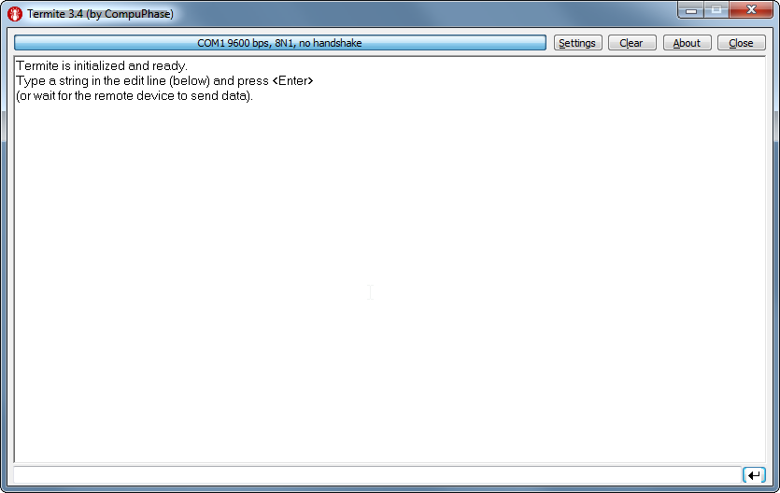

You should only need to select the relevant COM port to connect

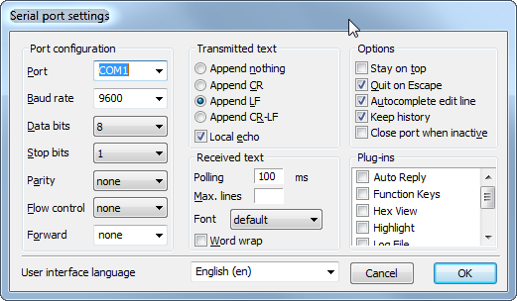

Exit out of the settings then click connect.

The terminal will then read:

GMAS>

To read the IP address yes the following command: ipaddr

To read the subnet mask use: ipmask

To read the default gateway use: defgateway

In order to set the values simply type the address right afterwards:

ipaddr 192.168.1.3

This will set the IP address, and the PMAS will reply with “OK” at the very end.

At this point you must reset the PMAS by powering off and powering back on for the changes to take place